
IDH2 (R172G)
Catalog Number:CR-M 26321
Gene Symbol: IDH2; D2HGA2; ICD-M; IDH; IDHM; IDP; IDPM; mNADP-IDH
Description: Anti-IDH2 (R172G) Mouse Monoclonal Antibody

Background: Isocitrate dehydrogenase (IDH) catalyze the oxidative decarboxylation of
isocitrate to 2-oxoglutarate. The isocitrate and isopropylmalate dehydrogenases family has
three members, IDH1, IDH2 and IDH3. IDH2 plays a role in intermediary metabolism and
energy production. Defects in IDH2 are the
cause of D-2-hydroxyglutaric aciduria type 2
(D2HGA2). Somatic mosaic mutations of this protein have also been found associated to Ollier disease and Maffucci syndrome, and R172G
IDH2 mutations do exist in diffusely infiltrative gliomas.
Immunogen: A synthetic peptide from the internal region ofIDH2 which includes the mutation of R172G, human origin.
Tested applications: ELISA, WB, IHC Recommended dilutions:
ELISA: 1:1000-1:5000
WB: 1:100-1:1000
IHC: 1:50-1:100
Concentration: 1 mg/ml
Host: Mouse
Clonality: Monoclonal
Purity: Purified from ascites
Format: Liquid Storage buffer:
Preservative: no
Constituents: PBS (without Mg2+ and Ca2+), pH 7.4, 150 mM NaCl, 50% glycerol
Species Reactivity: recognizes R172G mutant, but not wild-type IDH2 of vertebrates.
Storage Conditions: Store at -20°C. Avoid

freeze / thaw cycles.
Western blot:
ID H2proteins
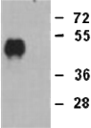

Western blot analysis of recombinant IDH2
(R172G) and wildtype proteins. Purified
His-tagged IDH2 (R172G) (lane 1) and
corresponding wild-type IDH2 protein (lane 2) were blotted with anti-IDH2 (R172G)
monoclonal antibody (Cat. #26321).

For research use only. Not for diagnostic or therapeutic applications.

Immunofluorescence:
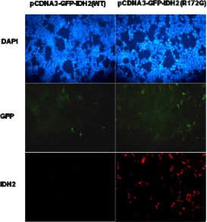
Immunofluorescence of cells expressing IDH2 proteins with anti-IDH2 (R172G) antibody.
HEK293T cells were transfected with
pCDNA3-GFP-IDH2 (WT) plasmid (left column) or pCDNA3-GFP-IDH2 (R172G) plasmid (right column), then fixed and stained with anti-IDH2
(R172G) monoclonal antibody (Cat. #26321).

